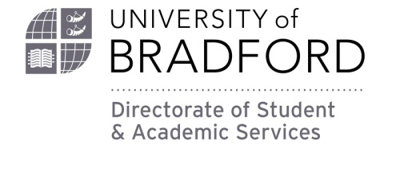

Baroness Lockwood Memorial Scholarship Trust 2020/21 - Star Student
Available to current female undergraduate students within the faculty of Engineering and Informatics.
Applicants can apply for this scholarship on the basis of academic excellence i.e. achieving exceptional results, or academic improvement throughout the duration of their time at Bradford. Students who have managed to achieve good results despite difficult circumstances are also invited to apply.
Students may also apply if they feel they have made an outstanding contribution to their course or fellow students, outside the area of academic achievement.
Students must submit a supporting statement from their personal tutor in support of their application.
Closing Date: Friday 2 April 2021 (late applications will not be considered)
If you do not fully complete this form, or fail to submit any required documents, your application for a Scholarship may not be considered.
About You:
Mrs Miss Ms Other
First name(s)
Surname
Date of Birth
Nationality
Home Address

Mobile Number
Email Address

Academic Details
Course Title
University of Bradford Student Number
Full Time or Part Time
Home EU or International Student

Funding/ Income
How are you funding your studies? Please tick where appropriate.
Student Finance England
Student Finance England EU Team
Student Finance Wales
Student Finance Northern Ireland
Student Awards Agency Scotland
Yourself/ Family/ Friends
Sponsor (please include details)

Personal Tutor’s Statement in Support of your Application
Students must submit a supporting statement from their personal tutor in support of their application. This can be attached to your application when submitted by email.

Personal Statement (please write below or attach to your application)
You must give a detailed statement in support of your scholarship application and provide proof of any results quoted. If you are applying on the grounds of contribution to your course or fellow students, please explain as clearly as possible what you do and the difference you make, as we will only have this statement and your tutor's comments by which to judge your application. Please also include why you have chosen to study in the field of Engineering and Technology and how your chosen course will help you achieve your future career goals.

How to submit your application
Please email your application and copies of your supporting documents to scholarships@bradford.ac.uk by the closing date of Friday 2 April 2021
Please note that this is a competitive application process, so not every application will be successful. If you haven’t heard from the University by the 15th May 2021, please assume that you have been unsuccessful. We are unable to provide individual feedback on applications.

Declaration
I declare that all the information I have supplied in this application is correct. If I am found to have submitted false information I understand that my application and/or any scholarship award will be discontinued immediately.
If I am awarded a Scholarship I give my consent for my profile to be featured on the University’s website and in other materials e.g. the prospectus.
Signed ………………………………………………………………………………………………………………………………………………………….
(you may type your name above)
Date ……………………………………………………………………………………………………

Please send this form to: scholarships@bradford.ac.uk
The deadline for this submission is Friday 2 April 2021

